Hi, everyone,

Firstly, Merry Christmas!
I have built a geometry using “rectangle” and a “interpolation curve” (which is new function in V 4.2a). The original source in the “interpolation curve” is a file (a series of x-y positions obtained from COMSOL using “export”), and then I import all the data into the software into a “Table”.
What I want to do is the rectangle substrate the area which the interpolation curve encompasses (the current interpolation curve is open one). I have tried to add a straight line to enclose the curve and convert them into a solid for the ”Boolean Operations-difference”. Even I add the straight line, “convert to solid”, or “union”, but all failed.

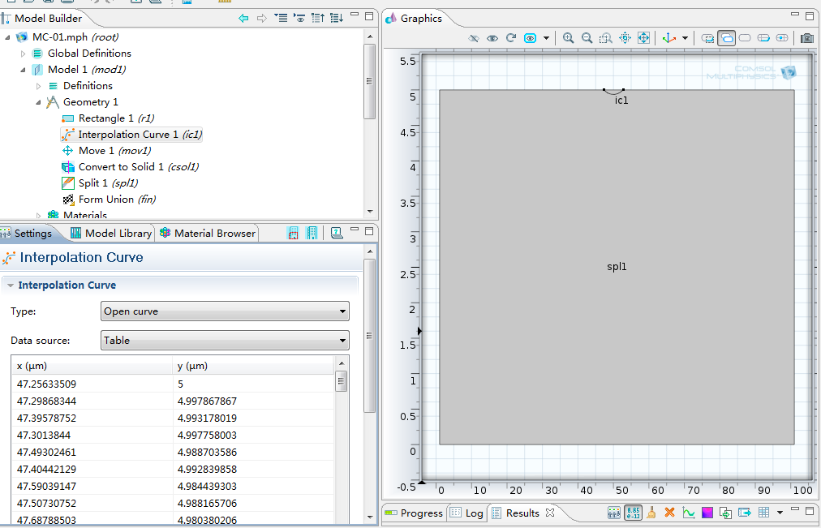

Is there any way to fulfill my aim?
Thanks in advance.
Best wishes to you and your family.

Yours
FM Huang
Dec. 25th.2011

