Problems relative to the temperature-dependent material properties

(All the content and photos are in the doc. attachment, Thanks)

Hi, everyone,

I'm building a thermal model using the "heat transfer module", in which the temperature-dependent material properties are applied, while it fails. Could you do me a favor to check my model and give me some suggest? Thanks sincerely in advance.

According to all what I known, I definite three "Piecewise function" just under the Model 1 --> Materials --> Material 1 --> Basic branch, just shown in Fig. 1. The three Piecewise functions with the names of d, tc and hc represent density, thermal conductivity and heat capacity, respectively. I judge there is something wrong with the temperature dependent material properties because the solved temperature distribution is same with the one when all the three material properties are constant in all range, i.e. density is equal to d_s irrespective of the temperature. Meanwhile, there is an effective heat capacity (including in the expression/function of the hc Piecewise function) to consider the phase change, the temperature should be different theoretically.

After a long time check and correct, I have not solve the problem and haven't understood what is wrong? Could you give me some help?
Thanks for your help. Best wishes to you and your family.

Yours
FM Huang
Dec.17th.2011
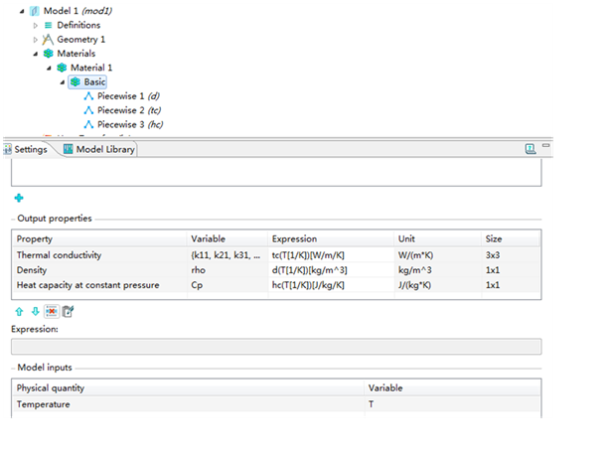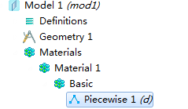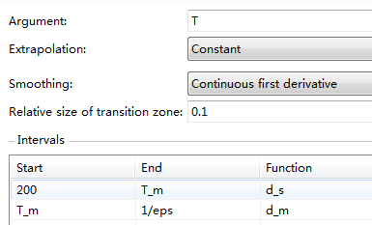
density
thermal conductivity
heat capacity
the detailed material properties/output:
input:
expression
(including de-unit, unit and argument)
name
General look
Detailas of the density function (d)
Fig. 1 Definition, expression and others relative to the temperature dependent material properties
p.s. the T_m, d_s and d_m are global parameters (constant)

