Hello, everyone

I’m trying to build a laser heat model, which is shown in the attachment. but this model has some Troubles, could you do me a favor to guide me ? thanks in advance sincerely.
Firstly, the I treat the laser beam as a “heat flux” (BC) with “General inward heat flux” instead of a “boundary heat source”, I have searched and read the user’s guide (Heat Transfer Module Users' Guide) and the detailes interpretation is as follows :
boundary heat source
The Boundary Heat Source feature models a heat source (or heat sink) that is embedded in the boundary.
And
heat flux
Use the Heat Flux feature to add heat flux across boundaries.
I’m a little puzzle with both. In my case, the only the material surface absorb the laser energy which means it should be a boundary condition. could you give some instruction to how to choose and which one is right?

Secondly, the resultant temperature distribution is quite strange and abnormal, just illustrated in the Fig. 1.
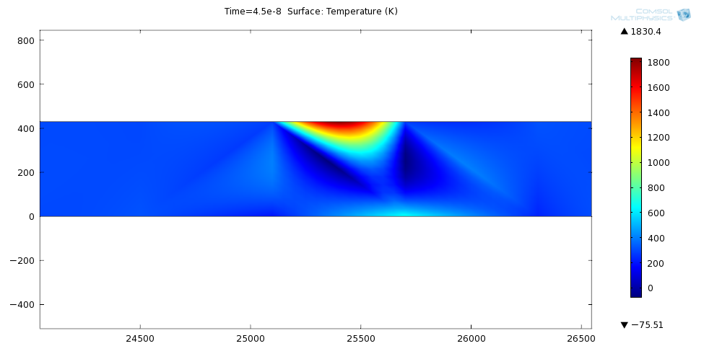
Because my initial condition of the domain is all 300K, and the boundary condition is thermal insulation, so all the temperature in the domain should be bigger than 300K, but the resolved temperature is quite contradictory to the common sence. I have tried to check the model, only to find nothing. Could you anyone help me, thanks.
Does the wrong implementation of the laser source lead to the xx result ?

FM Huang
2011-10-27

