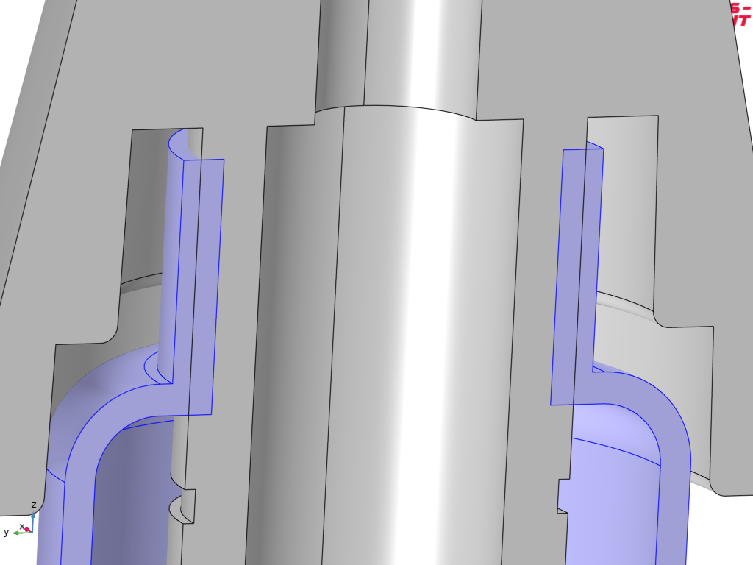
Figure 1: Gaiter domain (blue) in it's initial position
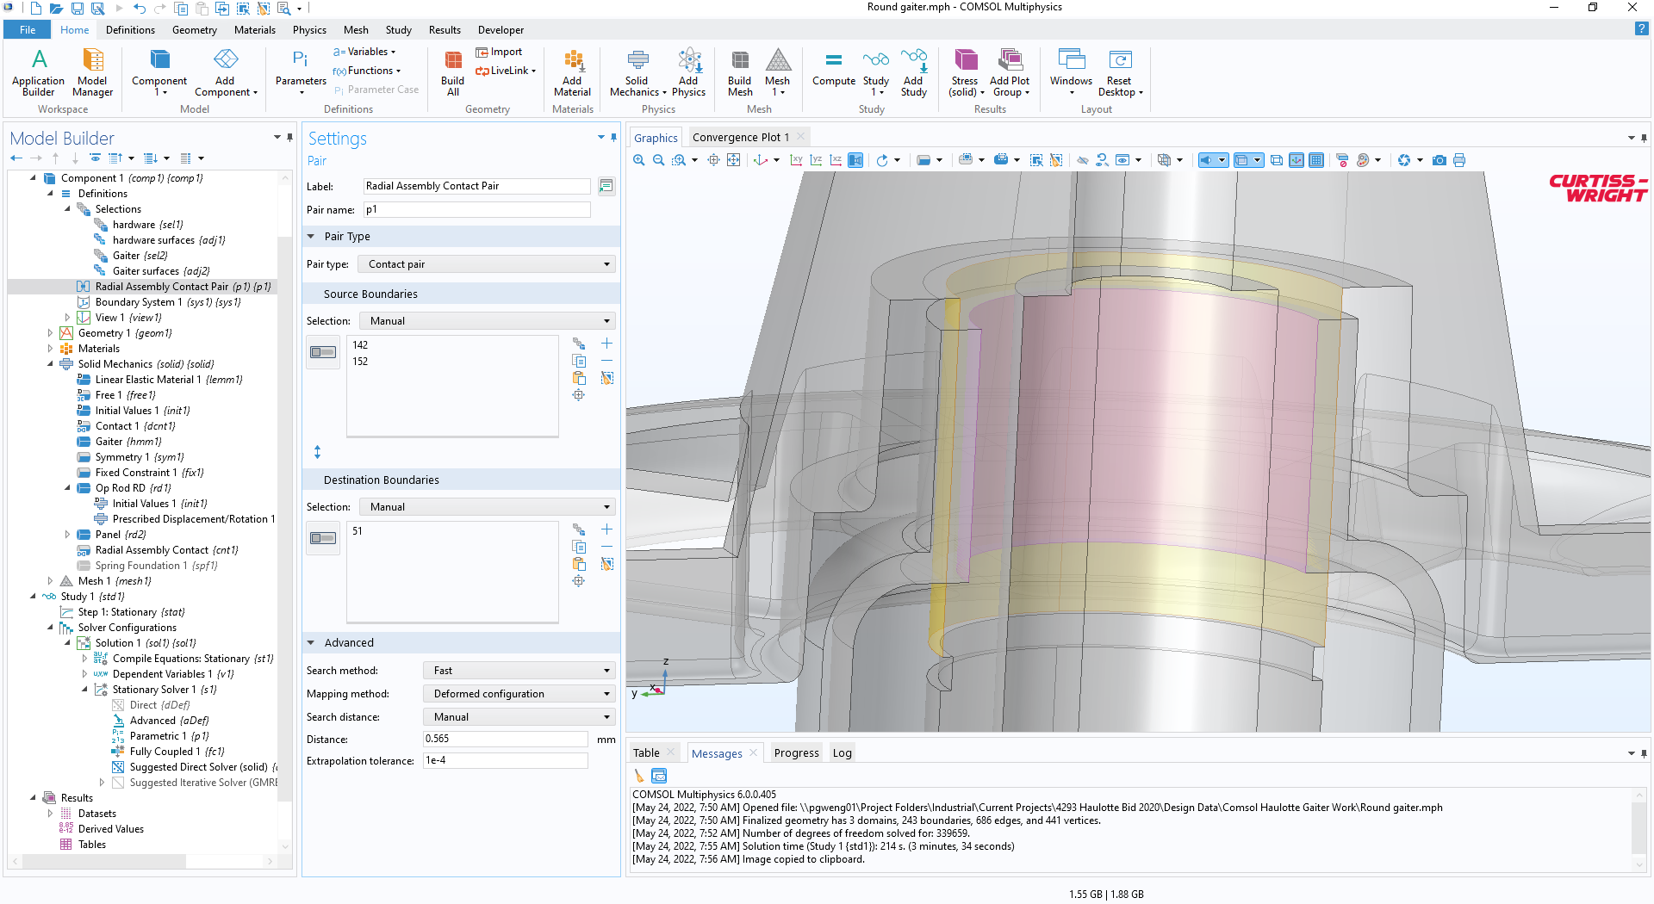
Figure 2: Contact pair settings for radial "snap" onto shaft OD
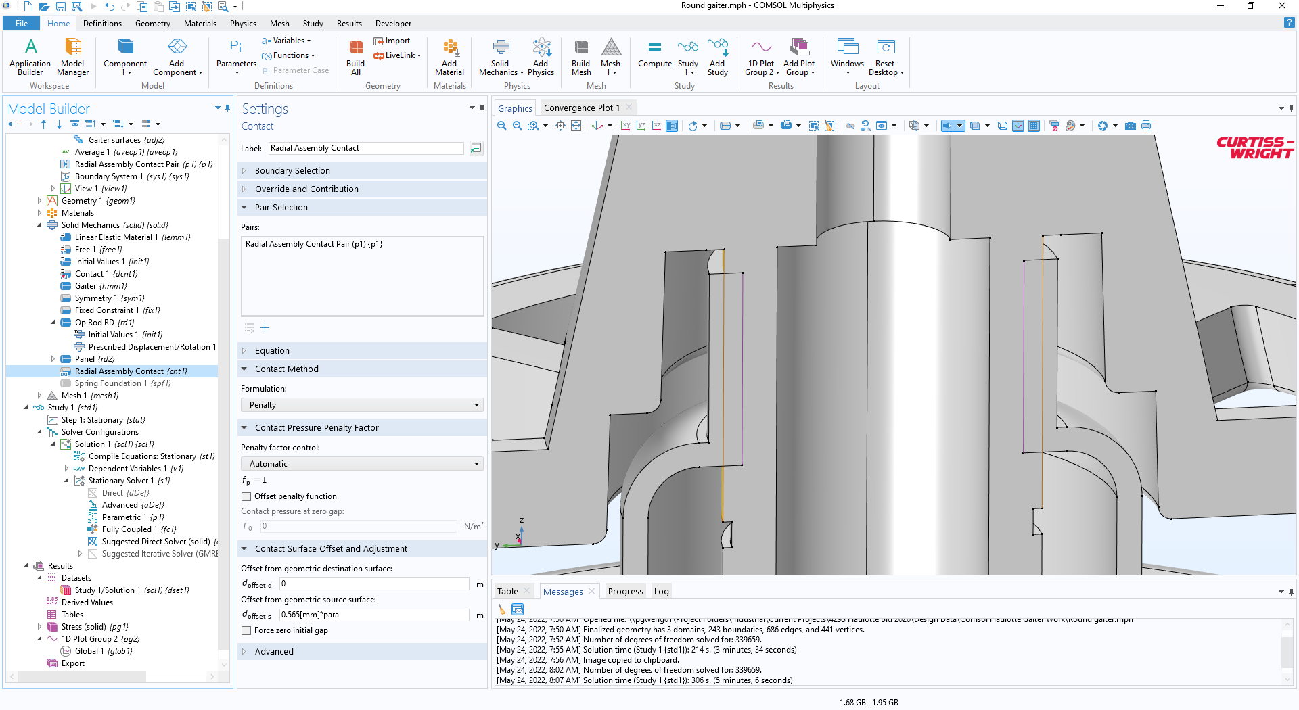
Figure 3: Contact condition settings for radial snap
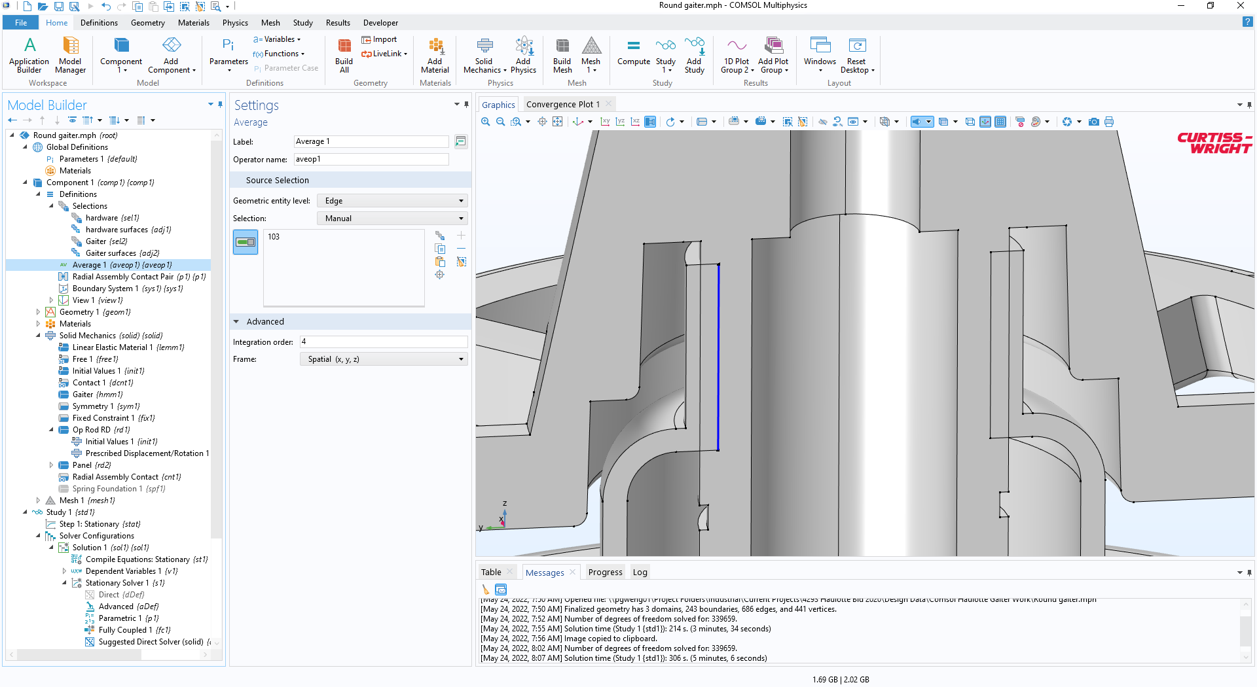
Figure 4: Aveop1 function (line)
The model uses an auxiliary sweep of a dimensionless parameter (“para”) using range(0,0.25,1) to progress from initial condition to the assembled condition.
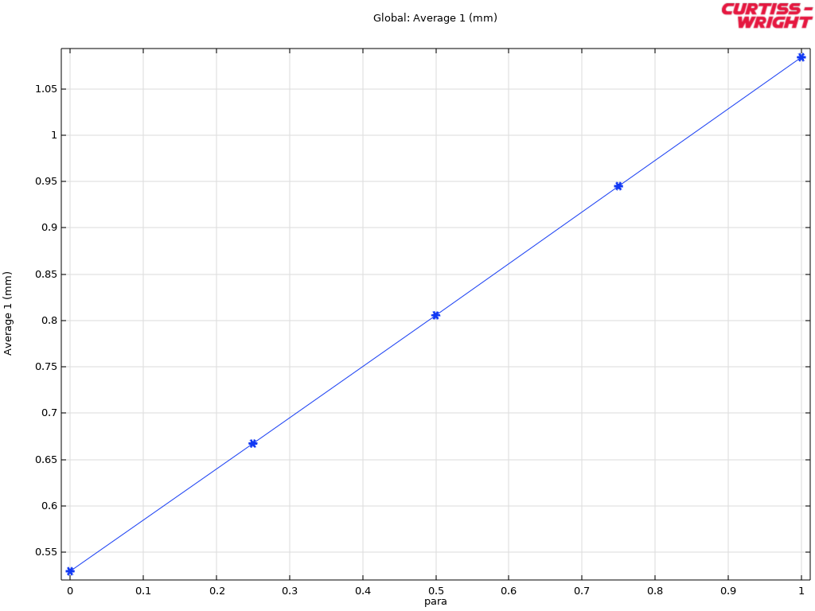
Figure 5: average displacement of gaiter - seems to be almost double the defined displacement
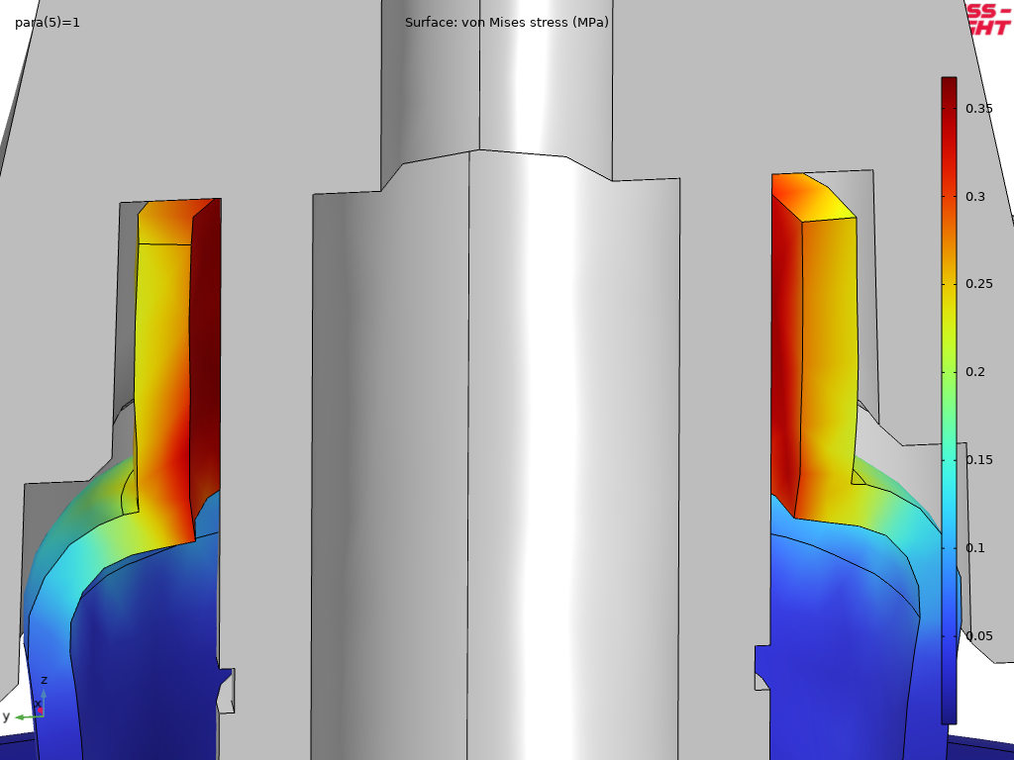
Figure 6: Final displacement in assembled position

