A transient heat transfer problem, the geometry see the figure below, there are two domains, the material of domain 1 is different from that of domain 2. For the boundary conditions, a fixed temperature on boundary 7 (for example, 100 [degC]), a fixed temperature on interior boundary 4 (for example, 0 [degC]), other boundaries are all insulated. The initial conditions for the two domains are 0 [degC].
Geometry: 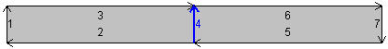
I want to get the heat fluxes of the upside /downside of the interior boundary 4, so I define such variables as below (Method 1 and Method 2, kS and kL are thermal conductivities), the difference between the two methods is the “Geometric Scope”, which one is correct?
Method 1: Method 2:
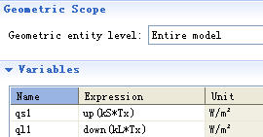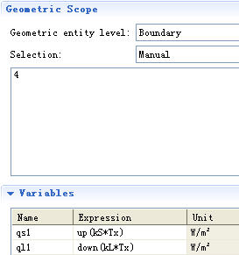
----------------------------------------------------------------------------------------------------------------------
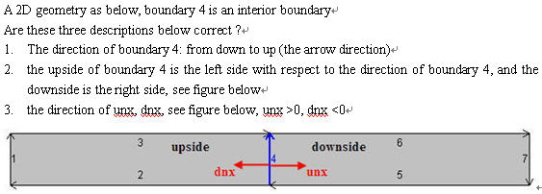
The up normal (unx) is the outward normal from the upside.
----------------------------------------------------------------------------------------------------------------------
I am a new user of the Level Set Module, below is a simple model I made:
The geometry is composed of a rectangle (Width=0.01m, Height=0.001m) and a line, just as the figure show.
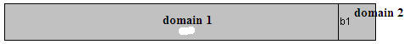
My goal is to make the line (interior boundary) move toward (to the left) with a certain velocity. I used the Level Set Physics only, all settings are as follows:
Level Set Model: : 2e-5, : ls.hmax/2, ux: -2e-5, uy: 0
Initial values 1: select domain 1, phi = 0
Initial values 2: select domain 2, phi = 1
Initial Interface: select the line (interior boundary, b1)
No flow: select all boundaries except the b1
----------
The result is shown as below. I just want the boundary, b1 to move toward, but the result is the entire domain 2 moves toward. How should I do to just make b1 move toward? (I know ALE method can do it, what about Level set ?)



