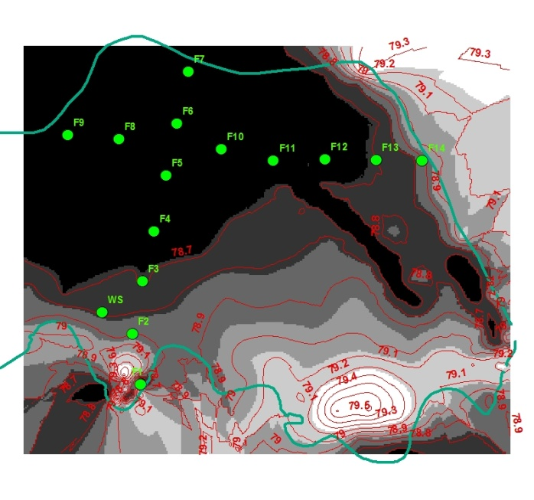 | 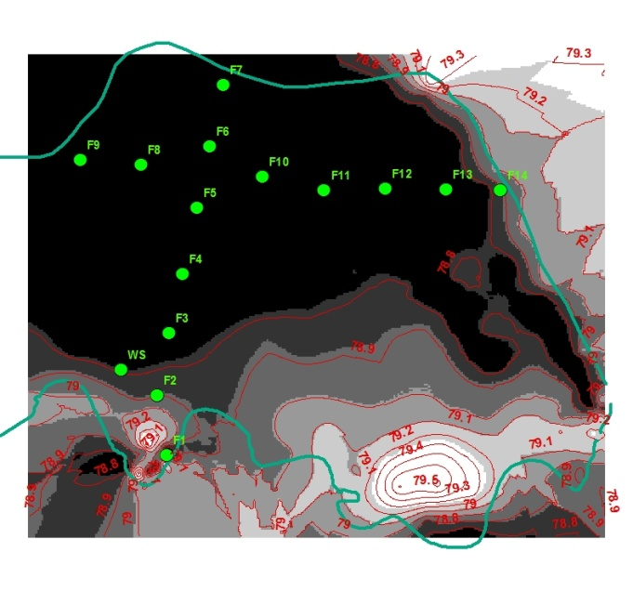
After 1 hr | After 8 hrs
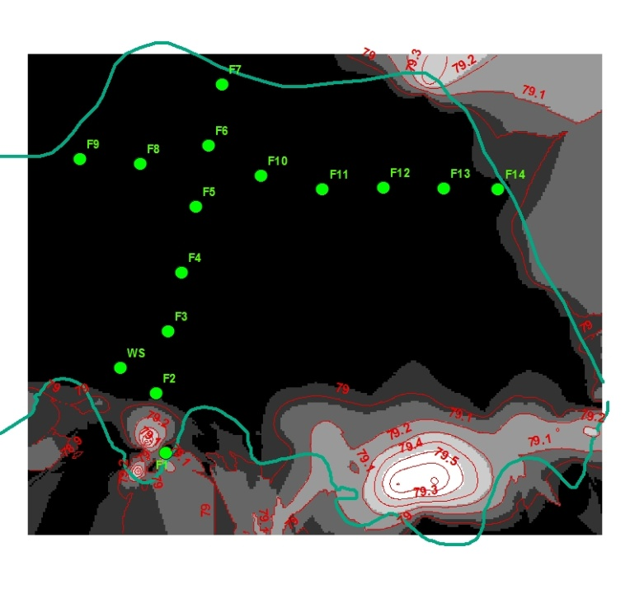 | 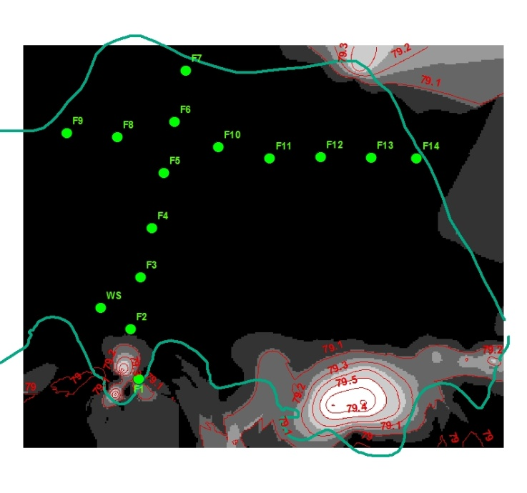
After 15hrs | After 22hrs
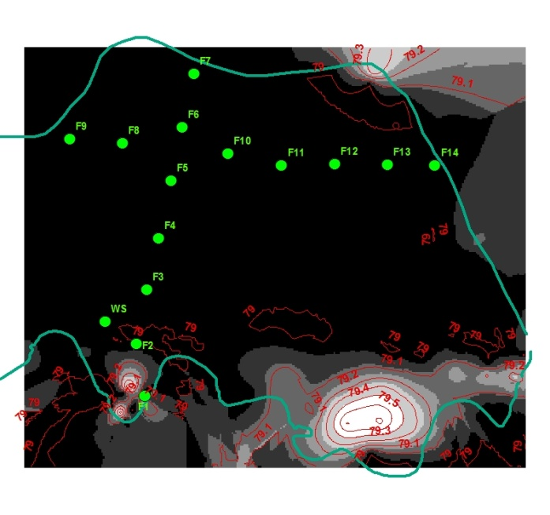 | 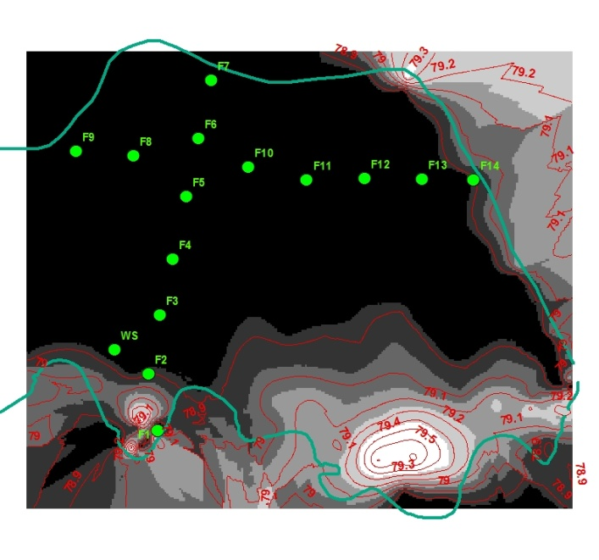
After 29hrs | After 36hrs
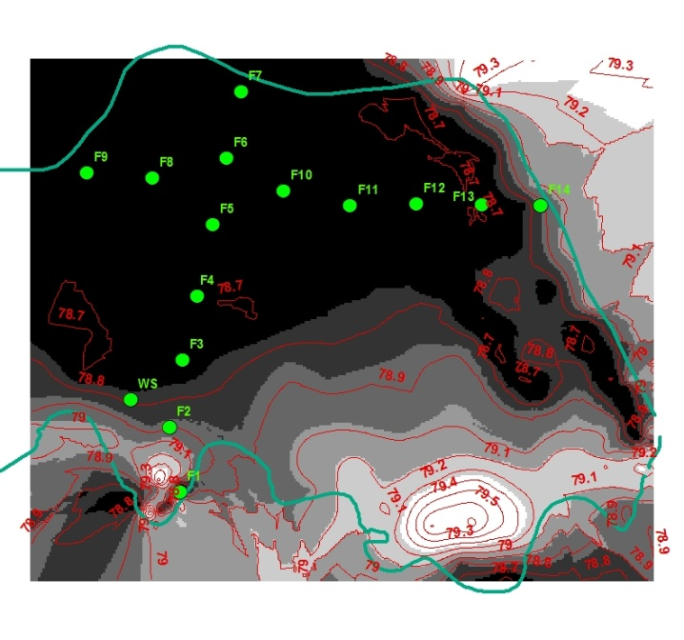 | 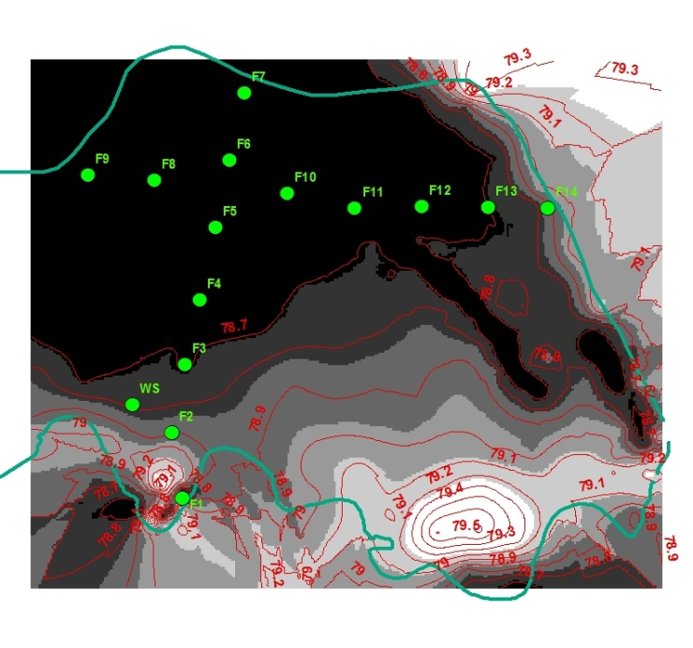
After 43hrs | After 50hrs
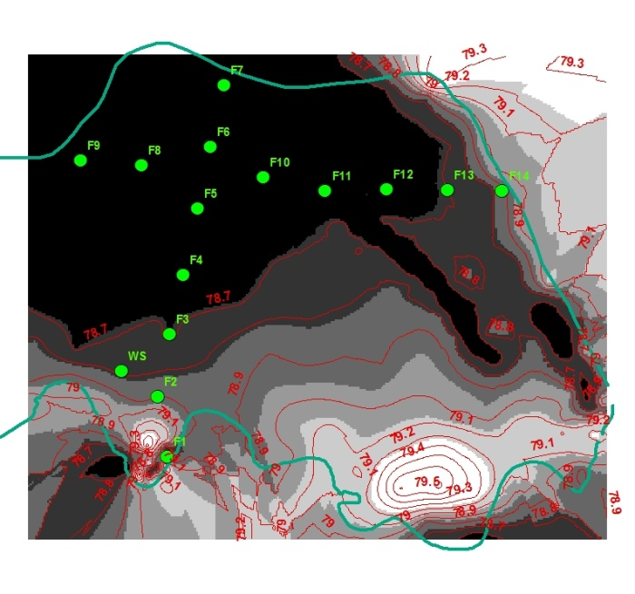 | 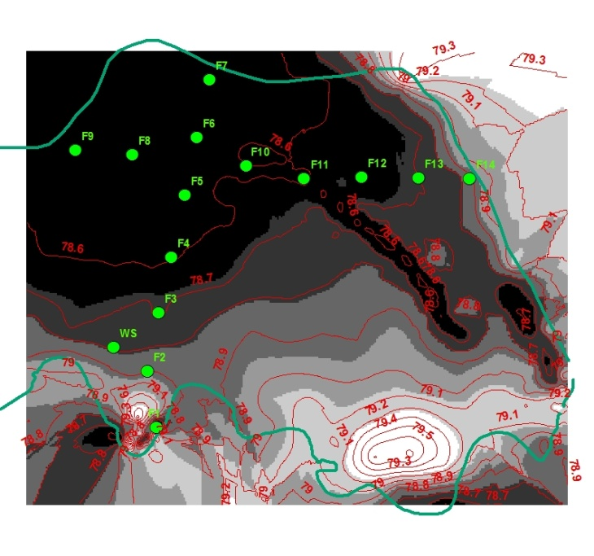
After 57hrs | After 64hrs
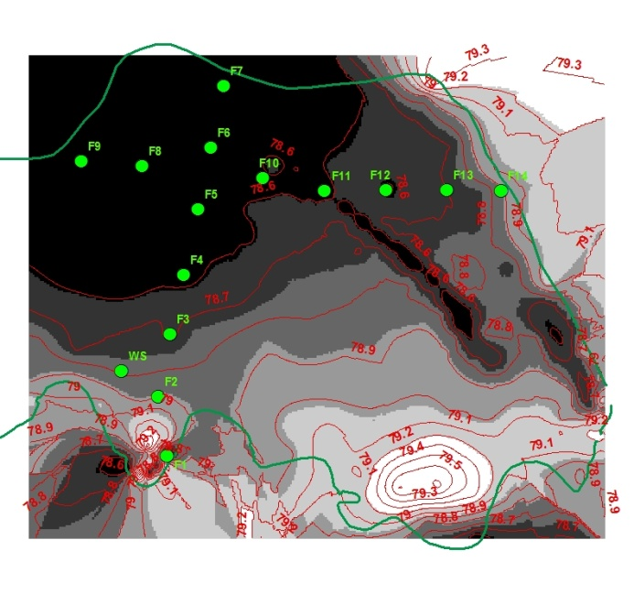 | 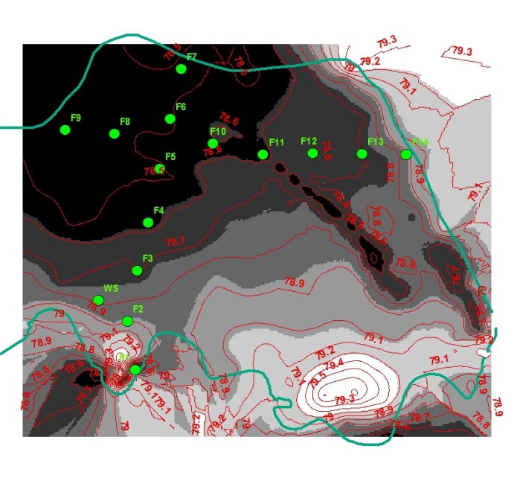
After 71hrs | After 73hrs
The black polygons are showing the inundated areas for one flood event starting from 3:00:00 5/28/2007 till 3:00:00 5/31/2007. These contour lines and inundated areas were prepared by Matlab and ArcGIS.
Spillway was defined by green oval in all the maps.

