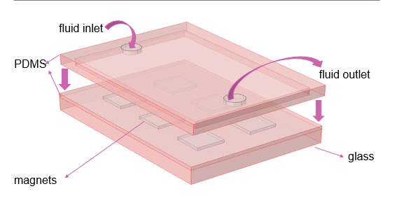
This is a simple model has different layes.
Bottom layer is glass:
Magnets array over glass enclosed by PDMS layer:
PDMS layer on top of this PDMS layer having a rectangular channel over magnets.

