We are trying to find the wave functions which are solutions of the Schroedinger equation for square potential box in 2D.
-We use COMSOL- PDE in the coefficient form with the following data:
Parameters: hbar=6.582118e-16, mo=9.10938e-31, ee=1.602176e-19 and the variable “ac=(hbar^2/(2*mo))*ee”

And One Coefficiente Form PDE 1 with the data:

Diffusion Coefficient ‘’c’’ in the diagonal form equal to ‘’ac’’,
the absorption coefficient ‘’a’’=3.5,
Damping or Mass Coefficient equal to one,
and the others parameters set to 0.

We are using the Dirichet Boundary Conditions at the 4 sides of the square of 10nm of side.

Finally, the mesh is adjusted as ‘’extra fine’’ in the default option in the mesh, and we obtained the following graphs:
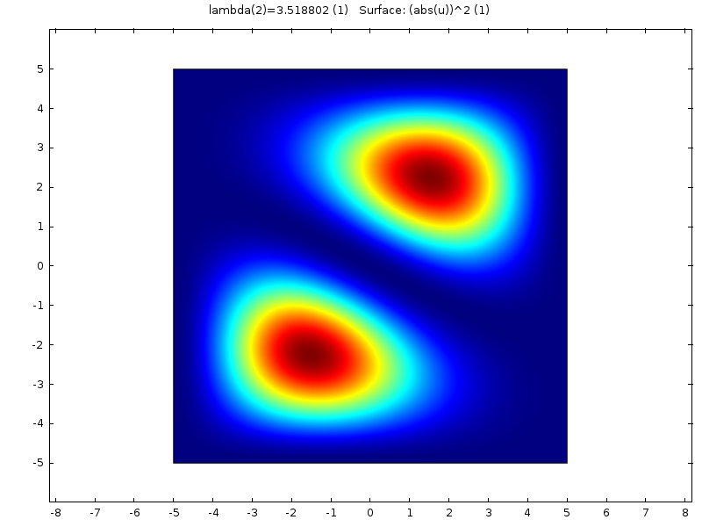
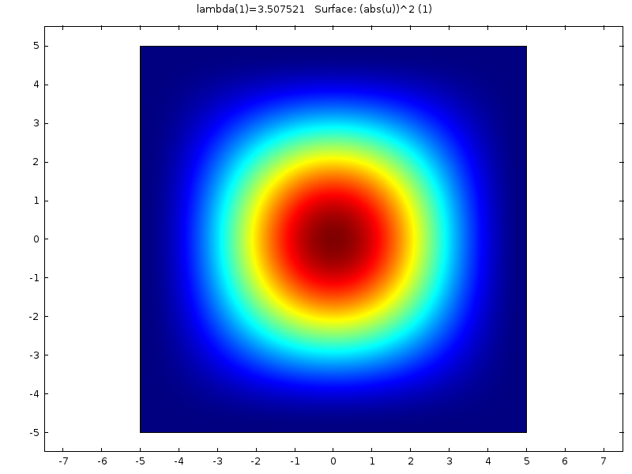
Nodal line

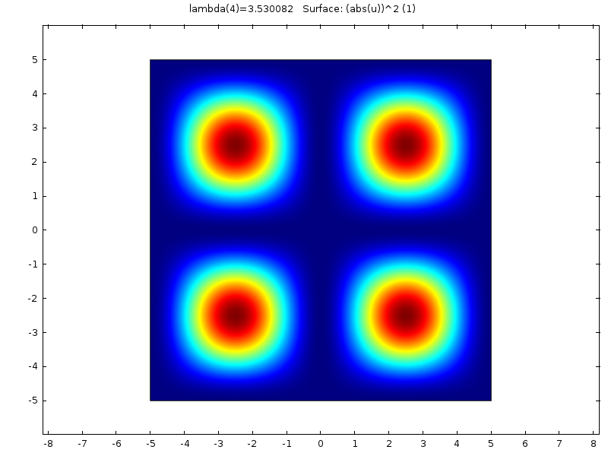
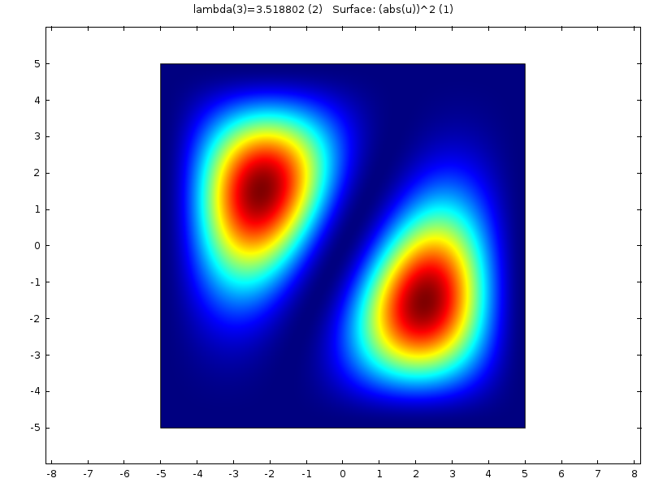

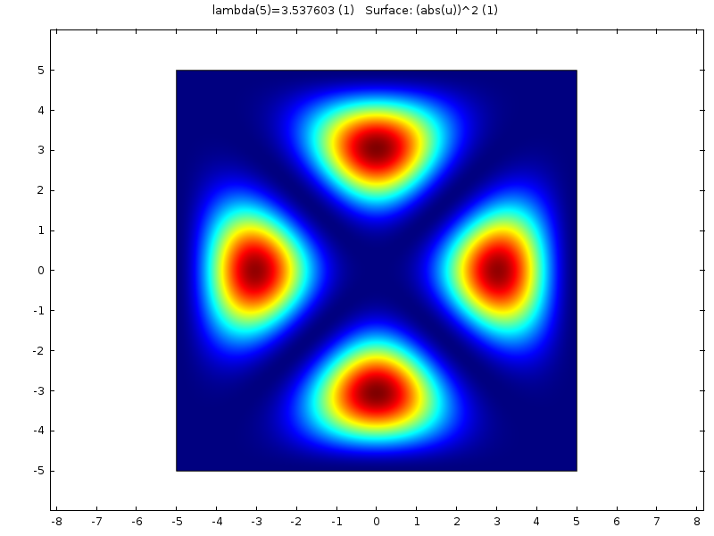

Now the mesh was changed to Free Quad, in size extremely fine and the obtained pictures were

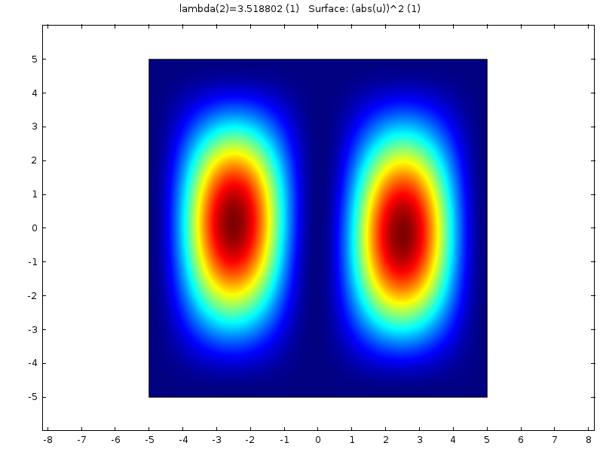
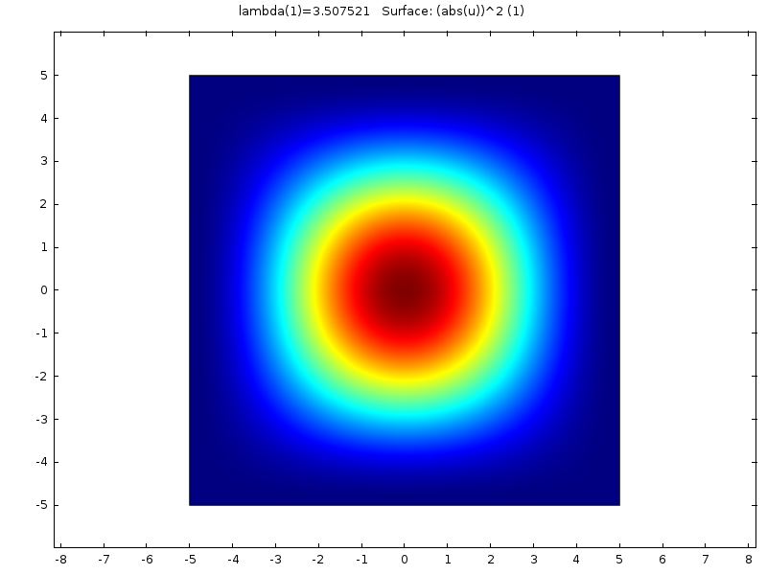

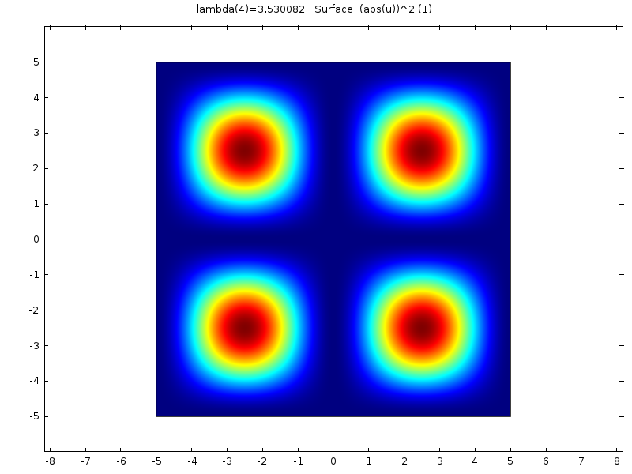
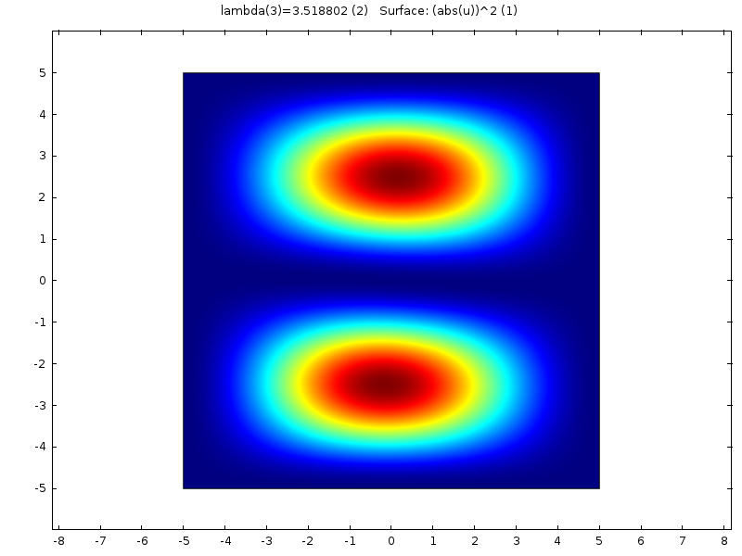

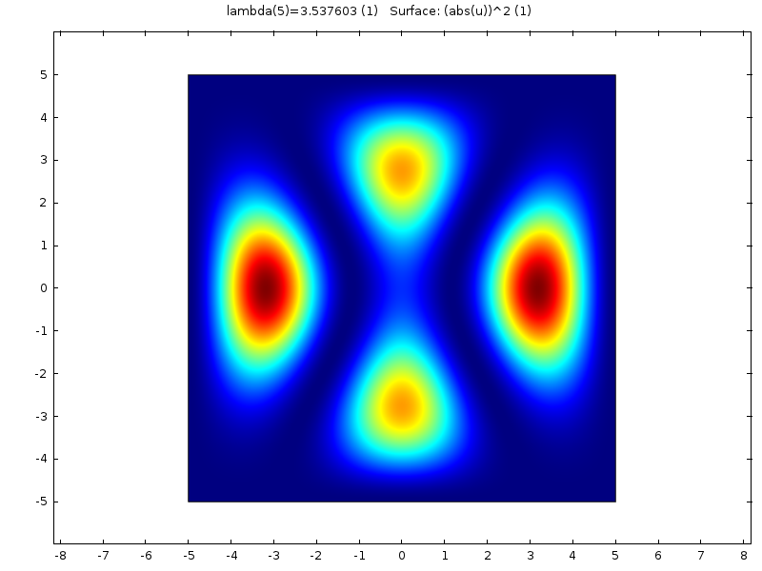

And finally we change the mesh to Mapped in extremely fine mode
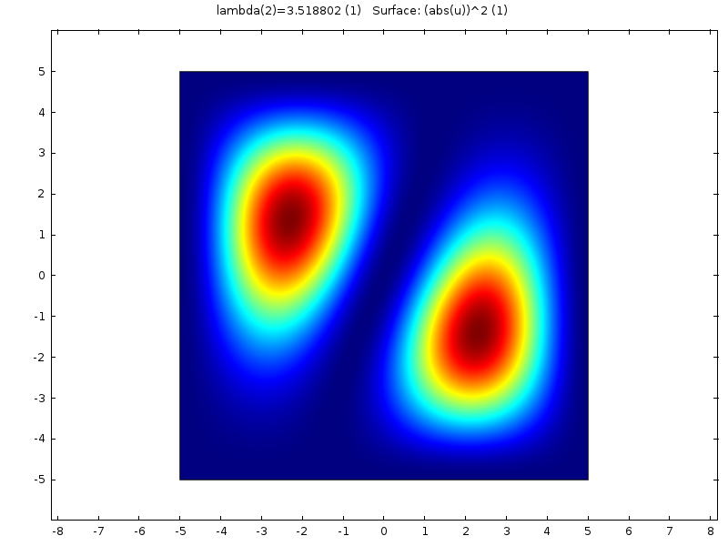
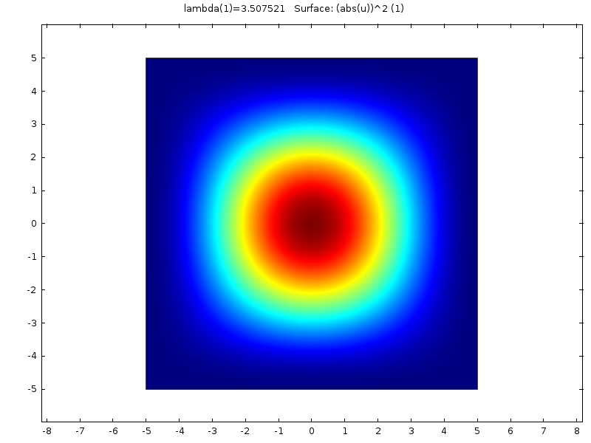
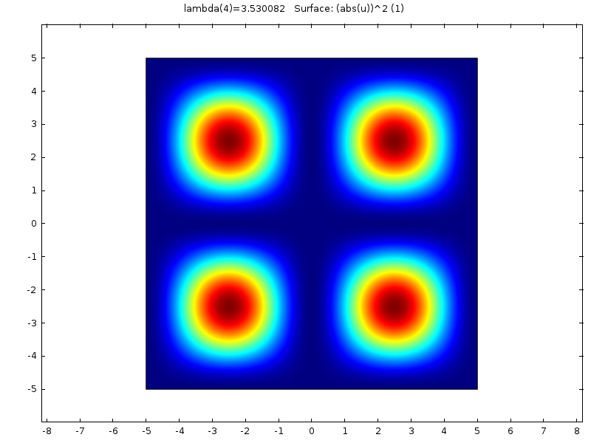
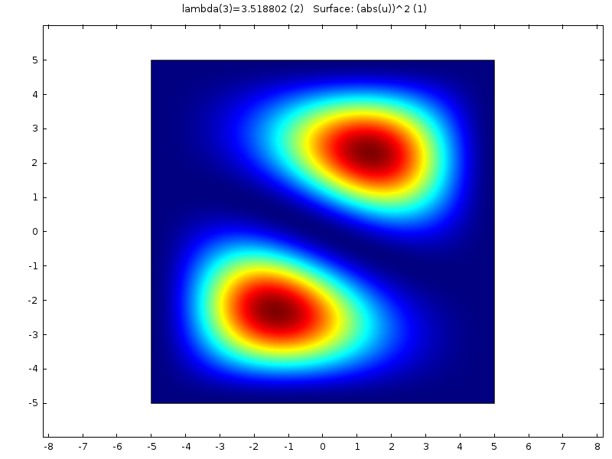

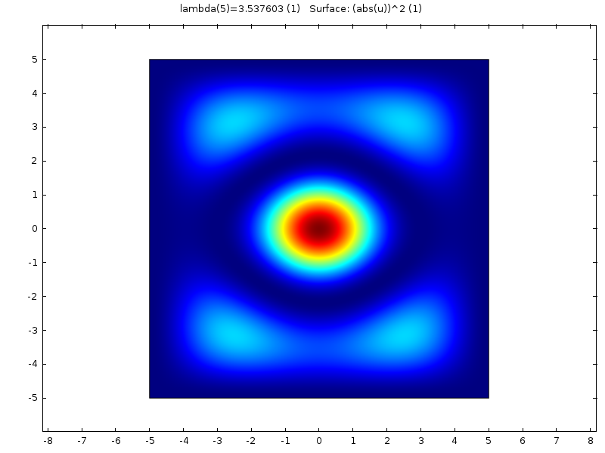

We found that all the solutions have the same energy, as it should be, but the form of the solution, (the wave function in COMSOL called “u”) changes with the choice of the mesh.
Analytically, the correct solution is a wave function, perfectly symmetrical, similar to obtained using a Free Quad mesh.

We found that the solutions (as obtained by COMSOL), are a linear combination of single solutions. However, the nodal line should be along the diagonal of square according to the analytical solution. This behavior is not observed and it turns out to be unexpected because it breaks the symmetry.

In fact, the system that we are studying is the 3D system, with a more complex geometry. We see a similar problem with the symmetry of the solution, because in theory the solution should be perfectly symmetric with respect to x,y axes.

We send this brief abstract waiting for an explanation and a possible solution to this problem. The mph file is attached too.

Thanks.

